Ty’s Horse Schedule
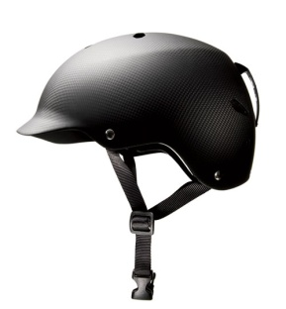 | Helmet On  Belt on
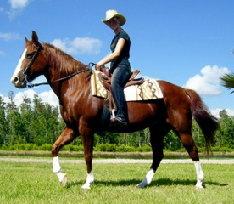 | Walk to Mounting Block  Ride Horse
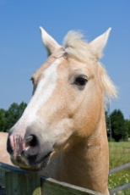  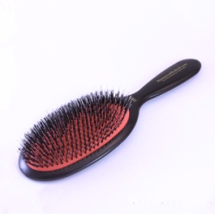 | Brush Horse
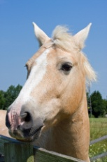  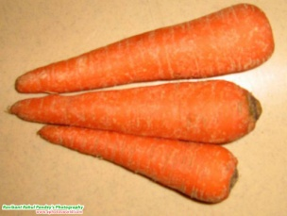 | Feed Horse Treat
Walk to Mom
Helmet Off
Reminders: No running away. _____  Quiet Voice. _____  Listening Ears. _____  Gentle Hands on Horse. _____  Working Hard. _____  Having Fun. _____ | ____________________________

