Matthew’s Horse Grooming Schedule
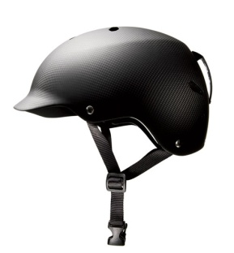 | Helmet On
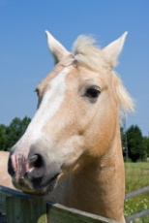  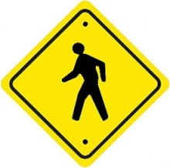 | Walk to Horse  Pet Horse 15 times on each side.
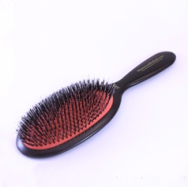 | Walk to get grooming bucket  Brush Horse 15 times ea side  *** PRIZE***
Walk to put bucket away.

Walk to kitchen.
Get treats.

Feed Horses Treats through stall feeders (No Allie, Shiloh or Kat)

*** PRIZE***
Walk to Mom
Helmet Off
*** PRIZE***

