Matthew’s Horse Feeding Schedule
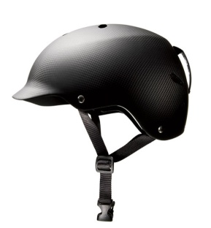 | Helmet On
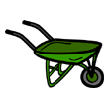  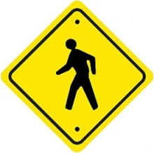 | Walk to Find Wheelbarrow
Put Hay Bale in Wheelbarrow
**PRIZE**

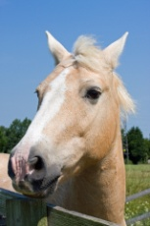 | Feed Horses:  **PRIZE**
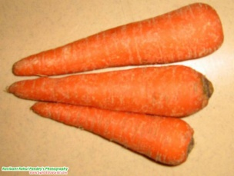 | Feed Horses Treats
Walk to Mom
Helmet Off
**PRIZE**

