Erika’s Happy Days Chart
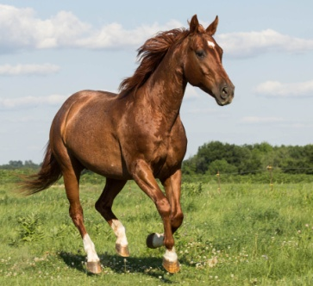
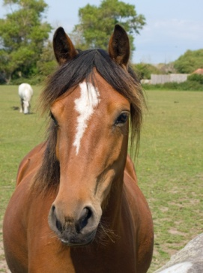
Erika loves horses and riding in her lessons with Missy. Riding outside is fun and playing games on Ruby is her favorite. Sometimes, Erika feels nervous, upset or mad when it is time to leave home and come to the barn. When Erika is cranky, mom feels sad and stressed. When Erika is flexible, cooperative and happy, mom feels calm and relaxed. Erika will earn a smiley face or a horseshoe for the chart when she is helpful and cooperative getting ready to come to ride at HorsePower. After 3 happy faces on the chart, Erika will get a very special treat.

Special Treat: ______________________________

