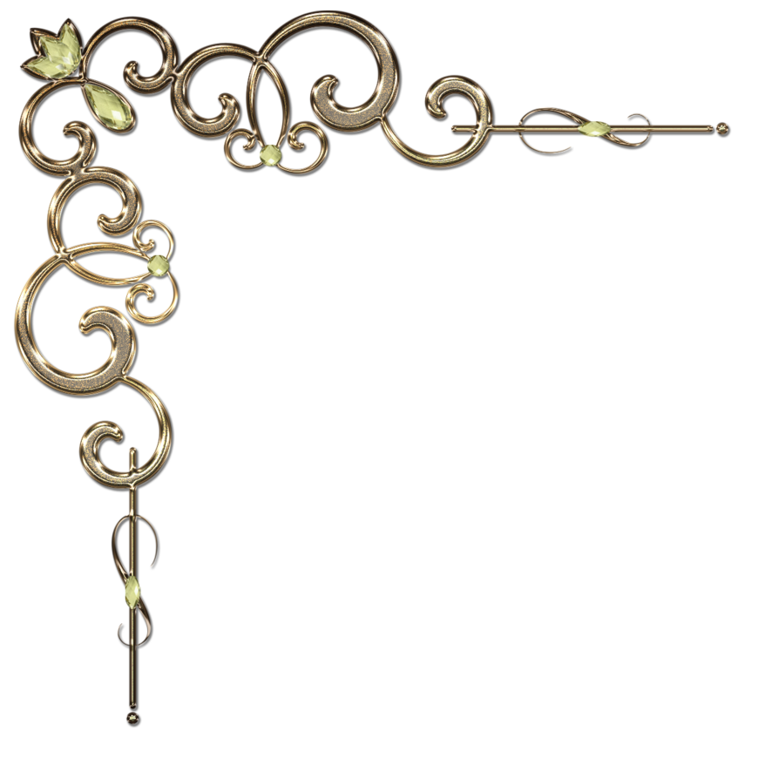

**Something New at HorsePower…… 30 Min Equine Spa Currying Sessions**

Why: The average school-horse burnout rate for the therapy horses is just 4 years. Our horses experience LARGE amounts of both physical and emotional stress in the work that they do with our riders. Physically unbalanced riders and riders with a lot of fear or noisiness have a bigger impact on these sensitive creatures than we realize. We intend to do all we can to help our horses feel great and you will see “30 Min Spa Curry” sessions on our clipboard schedule sheets.

How: Spend a FULL HALF HOUR with the horse, either in cross-ties or in the stall. Deep curry the large muscle areas with a “rough” rubber curry. Gently curry the face and legs with a “fine” rubber curry. Take extra time around the eyes, ears, poll, and lower legs. Notice the reaction of the horse and go deeper or more gentle depending on the signals they give you. Keep it quiet, soothing and relaxing. You may play music if you like.

Where: Either in cross-ties (if barn is relatively quiet) or in the stall (if the horse has hay to eat, or if barn is busy).